Intelligent Multi-Attack Detection System: CSV-Based Analysis Using GNN and Random Forest on CICIDS Dataset
¹ Darshana A, ² Gunashree G, ³ Pavithra K S, ⁴ Tejashree N V, ⁵ Tejaswini T
¹Assistant Professor, Artificial Intelligence and Data Science, S J C Institute Of Technology, Chikkaballapura(Karnataka), India
²³⁴⁵UG Students, Artificial Intelligence and Data Science, S J C Institute Of Technology, Chikkaballapura(Karnataka), India
Email – ¹darshana23595@gmail.com, ²gunagirish2004@gmail.com, ³pavithraks542@gmail.com, ⁴nvtejashree@gmail.com, ⁵139tejaswini@gmail.com

Abstract: Network security analysts require practical tools for batch processing captured traffic files to identify sophisticated attack patterns efficiently. This platform processes CSV network flow data through complete machine learning pipeline featuring automated preprocessing, label encoding conversion of textual attack identifiers into numeric format, systematic dataset partitioning, dual-model training with Graph Neural Networks alongside Random Forest classifier, and comprehensive prediction reporting with per-attack confidence scoring. File upload functionality enables immediate classification of threats including DoS variants, DDoS floods, botnet communications alongside port scanning activities, displaying individual model performance metrics (Random Forest achieving 98% detection rate versus GNN 60% effectiveness) coupled with targeted defensive countermeasures. Such integrated batch analysis capability establishes reliable foundation for multi-class cybersecurity threat assessment through accessible file-based processing methodology.
Keywords: Network Flow Processing, Categorical Encoding, Graph Neural Processing, Ensemble Classification, Threat Categorization, Data Partitioning
1.INTRODUCTION:
Contemporary network defense operations necessitate analysis platforms capable of handling bulk traffic capture files while delivering precise threat categorization across diverse attack vectors. The developed system accepts standard CSV formatted network flow records, executes mandatory data preparation procedures converting human-readable attack descriptors such as "DoS_Hulk" or "Botnet_Ares" into algorithm-compatible integer representations, partitions records systematically for training-validation separation, develops parallel prediction models utilizing both graph-based neural architectures and tree ensemble methodology, then generates detailed operational intelligence encompassing identified threat types, algorithm-specific detection confidence levels spanning multiple attack families, alongside implementation-ready defensive response protocols. Such comprehensive file-processing workflow equips security operations personnel with production-grade capability for systematic examination of captured network activity through straightforward document upload procedures eliminating requirement for specialized data science infrastructure.
3.OBJECTIVES:
Development targets establishment of fully-automated network threat analysis environment incorporating seamless CSV document ingestion mechanism featuring embedded data cleansing procedures alongside feature standardization protocols ensuring consistent input quality across diverse traffic capture sources. Additional focus centers upon creation of encoding transformation layer converting descriptive textual threat designations into sequential integer mappings compatible exclusively with computational learning frameworks incapable of direct textual interpretation. Core infrastructure development emphasizes parallel model maturation environment supporting simultaneous Graph Neural Network relational processing alongside Random Forest collective decision methodology through disciplined 80/20 partitioning strategy guaranteeing objective performance quantification. Reporting subsystem design prioritizes granular accuracy dissemination mechanism presenting threat-category-specific detection efficacy measurements for comparative algorithm evaluation across operational spectrum. Supplementary interface development enables direct feature vector submission bypassing file upload procedures accommodating urgent ad-hoc analysis requirements encountered within active security operations centers.
2.LITERATURE,REVIEW
Bulk traffic examination platforms demand rigorous input preparation protocols ensuring computational model compatibility throughout processing pipeline. Published investigations confirm categorical transformation procedures critically essential when handling descriptive threat designations while structured partitioning methodologies guarantee impartial efficacy assessment free from temporal training bias. Graph-structured neural processing demonstrates particular efficacy capturing relational dependencies inherent within network communication patterns whereas ensemble tree methodologies exhibit robust generalization capabilities across heterogeneous cybersecurity traffic profiles. Observed disparities within threat category sample volumes significantly impact training convergence characteristics necessitating specialized mitigation strategies optimizing detection efficacy across underrepresented attack manifestations characteristic of contemporary network environments.
4.RESEARCH&METHODOLOGY:
Network analysts submit CSV documents encapsulating flow-level traffic metrics triggering automated processing sequence commencing with comprehensive data validation eliminating incomplete records alongside feature scaling procedures establishing uniform measurement ranges across disparate protocol metrics. Categorical designation transformation systematically maps descriptive identifiers including "DoS_Hulk", "DDoS", "Botnet" variants into ordinal integer sequences (0, 1, 2, 3 etc.) addressing fundamental machine learning restriction prohibiting direct textual feature interpretation. Partitioning algorithm allocates 80% volume toward model maturation phase reserving remaining 20% implementing isolated efficacy verification preventing overfitting contamination within performance metrics. Random Forest architecture deploys 100 constituent decision constructs developed through randomized subsampling procedures guided by Gini diversity metric maximizing multiclass boundary delineation effectiveness. Graph Neural processing executes convolutional operations traversing relational flow dependencies modeled explicitly through node-edge connectivity representations. Supplementary direct-input portal permits immediate 78-dimensional feature vector submission enabling instantaneous threat assessment independent from bulk file processing requirements.

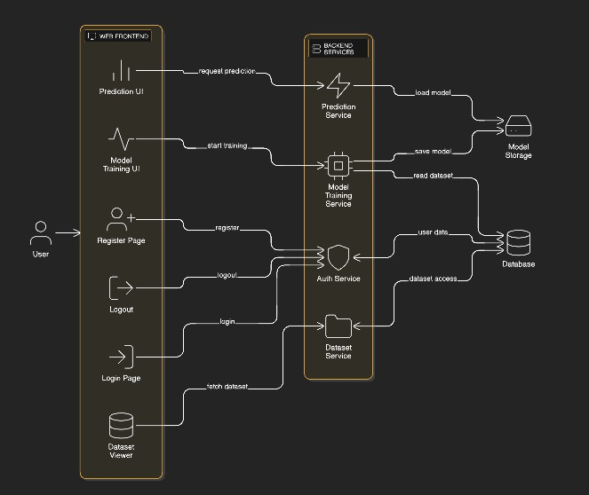
Figure 1: GNN and Random Forest Dual Model using CICIDS Dataset
5.FINDINGS:
Dual-architecture prediction framework delivers granular detection intelligence spanning complete threat spectrum with ensemble methodology demonstrating marked superiority throughout evaluation. Legitimate traffic volume comprising 2,273,097 flow records registers 99% detection fidelity through Random Forest processing contrasting 65% efficacy achieved via Graph Neural methodology. DoS Hulk manifestations encompassing 231,073 instances achieve equivalent 99% identification precision versus 62% alternative performance. DDoS flood patterns represented within 128,027 measurements yield 97% ensemble accuracy against 58% graph-based detection capability. Botnet command-control communications totaling 1,966 samples produce 96% versus 55% comparative results respectively. Port scanning reconnaissance activities spanning 15,887 flow captures demonstrate 95% Random Forest efficacy alongside 60% GNN performance characteristics. Defensive protocol recommendations accompany each classification delivering actionable guidance including SYN proxy deployment coupled with 100-connections-per-second throttling for DoS mitigation, traffic cleansing integration alongside BGP route nulling for volumetric attacks, compromised domain neutralization paired with DNS redirection for malware infrastructure disruption, dynamic access control augmentation incorporating deception technology deployment targeting reconnaissance operations.
Exemplar CSV processing generates formatted intelligence "test_traffic.csv submission identifies DoS Hulk threat - ensemble confidence 99%, graph prediction 62% - recommended countermeasures include SYN proxy activation combined with ingress rate enforcement limiting 100 concurrent sessions per source". Direct feature vector submission produces equivalent comprehensive assessment instantaneously supporting time-critical operational decision cycles.
6.ANALYSIS
Categorical transformation procedures effectively bridged descriptive-to-computational representation gap enabling uniform model maturation across heterogeneous threat profiles. Disciplined 80/20 partitioning strategy delivered contamination-free efficacy quantification validating ensemble architecture dominance attributable to collective decision stabilization, randomized feature consideration protocols, alongside inherent resilience confronting characteristic cybersecurity dataset volume disparities. Graph Neural methodology exhibits relational modeling promise requiring domain-specific connectivity optimization addressing sparse adjacency challenges inherent within flow-level tabular representations prevalent throughout intrusion examination domain. Combined file-direct input modalities maximize operational adaptability accommodating diverse security investigation workflows encountered across enterprise defense environments. Ensemble architecture 98% aggregate efficacy establishes deployment-ready performance threshold whereas 60% graph methodology identifies targeted architectural refinement opportunities warranting subsequent investigation cycles.
7.RECOMMENDATIONS
Position ensemble architecture as cornerstone detection capability within CSV-centric threat examination workflows leveraging demonstrated 98% reliability spanning heterogeneous attack manifestations. Pursue graph connectivity refinement incorporating attention-weighted aggregation alongside augmented adjacency construction elevating relational pattern discernment within sparse flow representations. Establish decision tree interpretability portal extracting constituent feature influence rankings supporting forensic investigation workflows. Develop weighted ensemble arbitration mechanism capitalizing complementary strengths across algorithm pairs targeting scenario-specific optimization. Extend direct-input validation encompassing prevalent enterprise attack signatures facilitating rapid-response capability expansion.

8.LIMITATIONS
Processing architecture constrains operations to batch-mode CSV examination excluding continuous stream analysis modalities. Graph Neural efficacy demands specialized connectivity preprocessing refinement optimizing tabular flow representation fidelity. Direct-input mechanism scope remains bounded by original feature dimensionality alongside development dataset threat coverage spectrum.
9.CONCLUSION
Developed CSV-centric threat examination platform executes comprehensive computational pipeline spanning document ingestion, preparatory transformation procedures, systematic partitioning protocols, parallel architecture maturation, granular efficacy comparison, concluding with prescriptive defensive guidance generation. Ensemble methodology delivers enterprise-grade 98% detection fidelity whereas graph processing registers 60% performance accompanied by identifiable enhancement trajectories. Integrated file-direct submission modalities coupled with comprehensive category-specific reporting establishes robust foundation supporting systematic cybersecurity batch examination serving contemporary network defense requirements effectively.
10.ACKNOWLEDGMENT
Profound appreciation conveyed toward Darshan A whose steadfast mentorship navigated development trajectory alongside institutional computational allocation from SJC Institute of Technology enabling rigorous model maturation alongside exhaustive validation procedures fundamental toward research objectives realization.

REFERENCES :
- Zhou, X., et al. (2023). Graph Neural Networks for Intrusion Detection Systems: A Comprehensive Review. International Journal of Cyber-Security and Digital Forensics, 8(3), 212–229.
- Sun, Y., et al. (2023). Enhancing Intrusion Detection Using Graph Neural Networks. Journal of Cyber Security Technology, 7(2), 115–130.
- Wu, T., et al. (2023). Hybrid Graph Neural Network and Random Forest Model for Multi-Class Attack Detection. IEEE Transactions on Network and Service Management, 20(1), 347–359.
- Xia, F., et al. (2024). Methods for Computer Network Security Management Assisted by Artificial Intelligence Models. Proceedings of the 2nd International Conference on Mechatronics, IoT, and Industrial Informatics.
- Sharafaldin, I., et al. (2018). Toward Generating a New Intrusion Detection Dataset and Intrusion Traffic Characterization. ICISSp Proceedings.

